https://shorturl.at/G2IAP 11 Dec 2024

G17 BEE
KickStart with Node.js https://shorturl.at/6DjNO
Creating HTTP Server
Sending custom response from http server

=======================================================
Implementing HTTP Server
=======================================================
- ‘http’ is the predefined module used to create http servers.
- http is the native module, so no need to download it.
- ‘require()’ is used to import.
- Eg let http = require(‘http’)
- ‘createServer()’ is the predefined function in http module.
- This function is used to create the server.
- The argument to createServer() is arrow function.
- To this arrow function there are two arguments, ‘req’ and ‘res’.
- request and response objects provided by node engine respectively.
- req object is used to store client data.
- res object is used to send response to client.
- 'writeHead(-,-)' is the predefined function in res object.
- This function is used to set the MIME type.
- First argument to this function is the status code (200 - ok).
- Second argument is the JSON object.
- JSON key is ‘content-type’ and the value is ‘text/html’.
- ‘write(-)’ is the predefined function in res object.
- This function is used to append response to res object.
- ‘end()’ is the predefined function in res object.
- This function is used to lock the response.

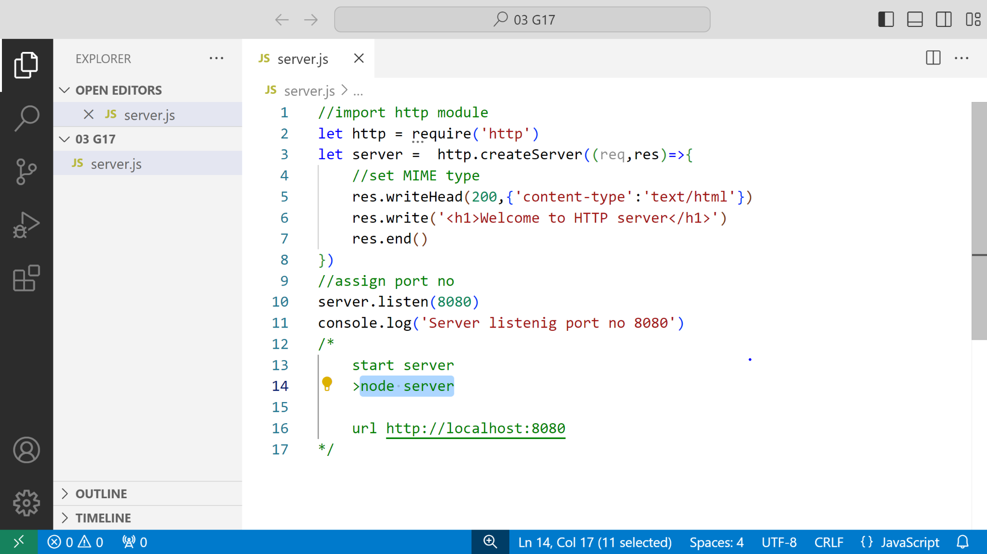

Task:-
Sending custom html response from http server
let resText = `Welcome to Http server`
let myResponse =
`
<!DOCTYPE html>
<html>
<head>
<style>
body{
background-color: black;
}
h1{
color: black;
text-shadow: 0px 0px 2px red;
}
</style>
</head>
<body>
<h1>${resText}</h1>
</body>
</html>
`
//import http module
let http = require('http')
let server = http.createServer((req,res)=>{
//set MIME type
res.writeHead(200,{'content-type':'text/html'})
res.write(myResponse)
res.end()
})
//assign port no
server.listen(8080)
console.log('Server listenig port no 8080')
/*
start server
>node server

url http://localhost:8080
*/

